**Verb Tenses Chart (http://www.eslcharts.com/verb-tenses-chart.html)**

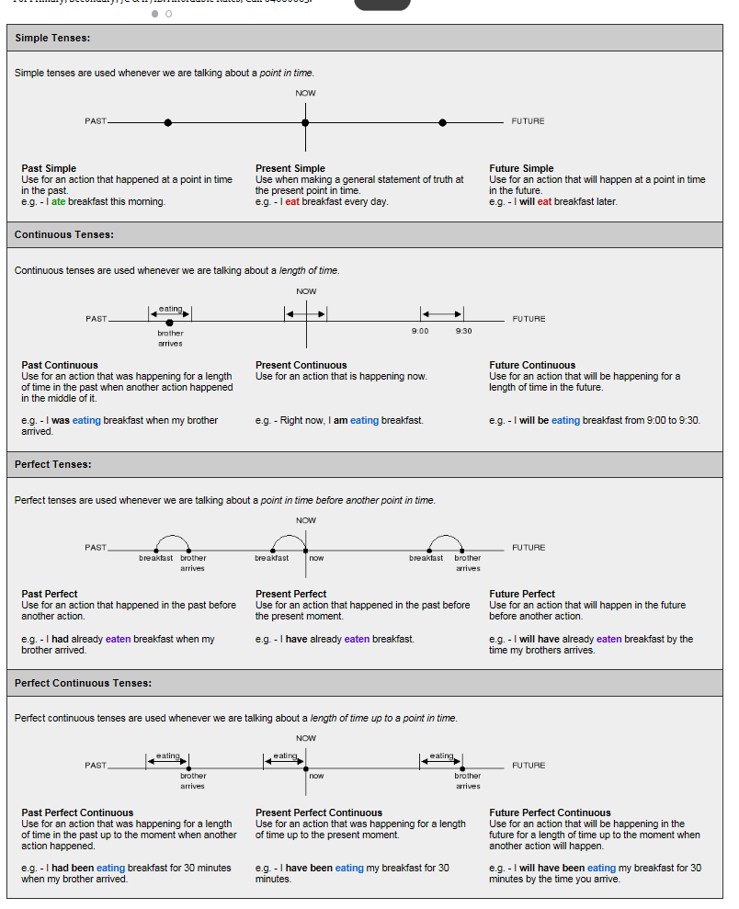

**Tenses table with more explanations of the main tenses**

|  |  |  |  |
| --- | --- | --- | --- |
| tense | How the verbs are written as a statements/Question | Use | Signal Words that the tenses should be used (emphasis is on time) |
| [**Simple Present**](http://www.ego4u.com/en/cram-up/grammar/simple-present) | **A:** He speaks.  **N:** He does not speak.  **Q:** Does he speak? | * action in the present taking place **once, never or several times** * facts * actions taking place one after another * action set by a timetable or schedule | always, every …, never, normally, often, seldom, sometimes, usually  if sentences type I (*If I* ***talk****, …*) |
| [**Present Progressive**](http://www.ego4u.com/en/cram-up/grammar/present-progressive) | **A:** He is speaking.  **N:** He is not speaking.  **Q:** Is he speaking? | * **action taking place in the moment of speaking** * action taking place only for a limited period of time * action arranged for the future | at the moment, just, just now, Listen!, Look!, now, right now |
| [**Simple Past**](http://www.ego4u.com/en/cram-up/grammar/simple-past) | **A:** He spoke.  **N:** He did not speak.  **Q:** Did he speak? | * action in the past taking place **once, never or several times** * actions taking place one after another * action taking place in the middle of another action | yesterday, 2 minutes ago, in 1990, the other day, last Friday  if sentence type II (*If I* ***talked****, …*) |
| [**Past Progressive**](http://www.ego4u.com/en/cram-up/grammar/past-progressive) | **A:** He was speaking.  **N:** He was not speaking.  **Q:** Was he speaking? | * action **going on** at a certain time in the past * actions taking place at the same time * action in the past that is interrupted by another action | when, while, as long as |
| [**Present Perfect Simple**](http://www.ego4u.com/en/cram-up/grammar/present-perfect-simple) | **A:** He has spoken.  **N:** He has not spoken.  **Q:** Has he spoken? | * putting emphasis on the **result** * action that is still going on * action that stopped recently * finished action that has an influence on the present * action that has taken place once, never or several times before the moment of speaking | already, ever, just, never, not yet, so far, till now, up to now |
| [**Present Perfect Progressive**](http://www.ego4u.com/en/cram-up/grammar/present-perfect-progressive) | **A:** He has been speaking.  **N:** He has not been speaking.  **Q:** Has he been speaking? | * putting emphasis on the **course or duration** (not the result) * action that recently stopped or is still going on * finished action that influenced the present | all day, for 4 years, since 1993, how long?, the whole week |
| [**Past Perfect Simple**](http://www.ego4u.com/en/cram-up/grammar/past-perfect-simple) | **A:** He had spoken.  **N:** He had not spoken.  **Q:** Had he spoken? | * action taking place before a certain time in the past * sometimes interchangeable with past perfect progressive * putting emphasis only on the **fact** (not the duration) | already, just, never, not yet, once, until that day  if sentence type III (*If I* ***had talked****, …*) |
| [**Past Perfect Progressive**](http://www.ego4u.com/en/cram-up/grammar/past-perfect-progressive) | **A:** He had been speaking.  **N:** He had not been speaking.  **Q:** Had he been speaking? | * action taking place before a certain time in the past * sometimes interchangeable with past perfect simple * putting emphasis on the **duration or course** of an action | for, since, the whole day, all day |

http://www.ego4u.com/en/cram-up/grammar/tenses

Another very good table: http://www.englisch-hilfen.de/en/grammar/tenses_table.pdf